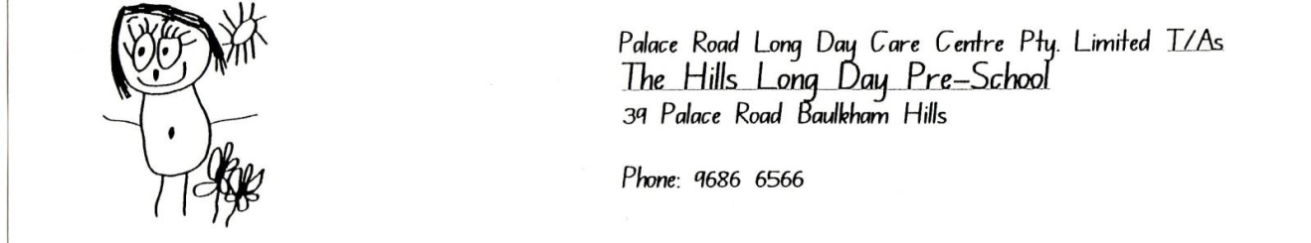

WAITING LIST APPLICATION FORM

Child’s Full Name:…………………………………………………………………..…Age:……………………

Male or Female D.O.B.:………………..
(please circle)

DESIRED STARTING DATE: DAYS TO ATTEND: M / T/ W/ TH/ F
(please circle)

Parent 1 –

Given Name:……………………………………………………………...D.O.B:…………………

Relationship to Child:………………………………… Phone Number:…………………………

Email:……………………………………………………Currently working? Yes / No (Please circle)
This includes study or maternity leave

Address:………………………………………………………………...... Post Code:…………….

Parent 2 –

Given Name:……………………………………………………………...D.O.B:…………………

Relationship to Child:………………………………… Phone Number:…………………………

Email:……………………………………………………Currently working? Yes / No (Please circle)
This includes study or maternity leave

Address:………………………………………………………………...... Post Code:…………….

PRIORITY IS GIVEN TO APPLICANTS ON THE WAITING LIST IN ACCORDANCE WITH THE GOVERNMENT’S PRIORITY OF ACCESS GUIDELINES. Once priority of access is determined, applicants are offered a position in order of the date of application.

…………………………………………………… …………………….
Applicant’s Signature – Relationship to child Dated
(mother, father, grandparent)

